Chemistry Game NKU
Hai Hoang

I. Introduction:

Chemistry game NKU was a project originially started as a memory game involving themes and study material from chemistry classes. This iteration of the project is a platform to store, host and to create games.

II. Project structure:
Database: The project uses PDO for SQL operations.
Database diagram:
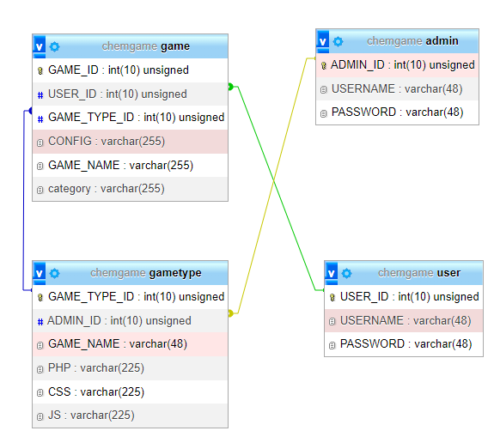
The database has a total of 4 tables following the businiess rules:
The Admin can create GameType
A User can create a Game
A Game is created using a GameType(Which is a template of the game) and supporting files (Config)
A Game type has a category

The relationships in the implementation of the database make it so that if a GameType were to be deleted by an Admin, the delete would cascade and also Delete the related games as well.

The structure of the project is as follows:
>Admin
>Game
>GameType
>User
>Views
>Settings

This project does not use any PHP frameworks but does its best to mimic some of the design of PHP frameworks, and is inspired by the MVC pattern used by Code Igniter.

The Views is seperated from the Model and Controller.
The View directory contains what the user will be able to see and navigate.
In the View directory, the user will be able to invode POST and GET requests using AJAX.
These requests are then passed on to the appropriate Module, which then will invoke the corrent method in the according Entity Class. Only an Entity class is able to communicate with the database.
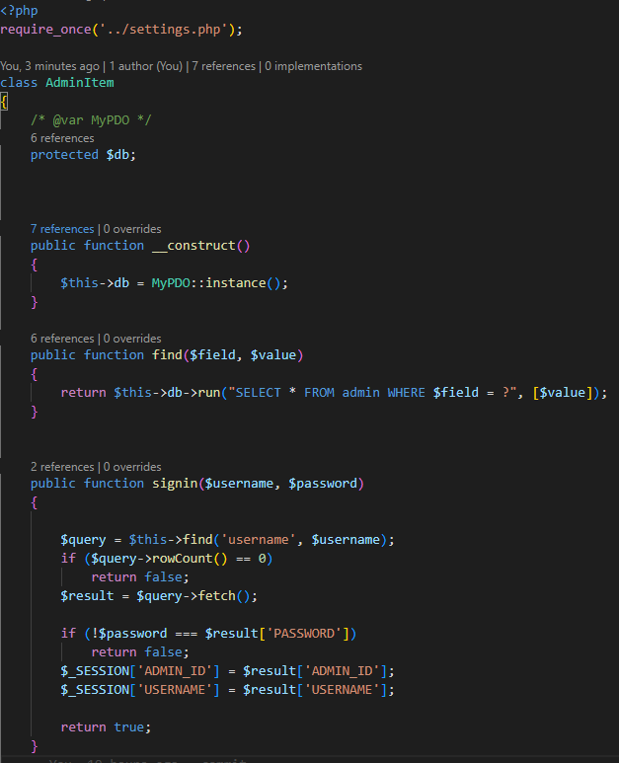
This is an excerpt of the class AdminItem
Each entity class creates an instance of MyPDO.
All the SQL queries are created in AdminItem and passed on to MyPDO.

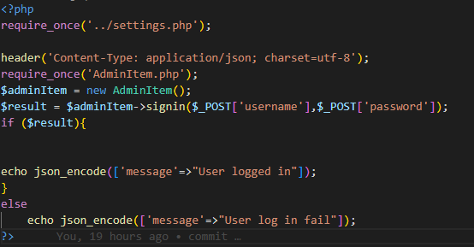
This is the contents of the adminLogin.php file.
When it receives a request from Views, it will format and pass the information to an instance of AdminItem(). When it gets a response from AdminItem, it will then respond to the request with a message.

You can change settings in the project by modifying the settings.php file. This file contains the configurations for the database as well as the MyPDO class.
The MyPDO class constucts a PDO object and contains static methods that are envoked by the Entity classes.
In the settings.php file, changing the constant ROOT to the appropriate directory is necessary for setting up the project.

III. User experience:

Upon first login to the site, the user (as the role of a visitor) sees the following:

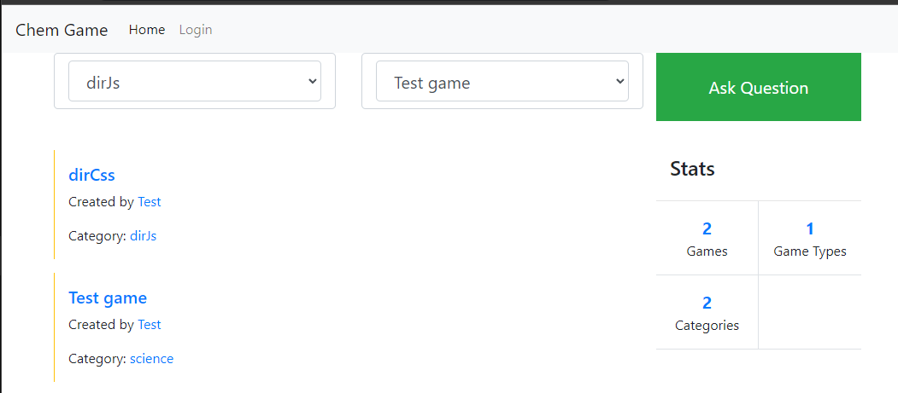
As a visitor, the user can immidiately select a game and start playing (playing a game has not been implmented yet). The user can also view the categories in the tab on the left or view the game types on the tab to the right.
The number of games, game types and categories and shown on the table to the bottom right.

There are also two additional pages, the Games page and the Game Types page.
The game page contains a list of all the games while the Game Types page contain a list of Game Types

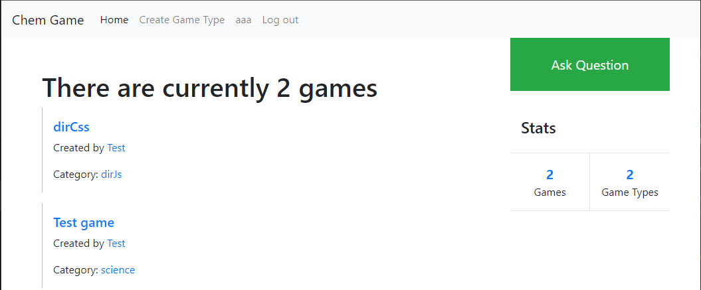
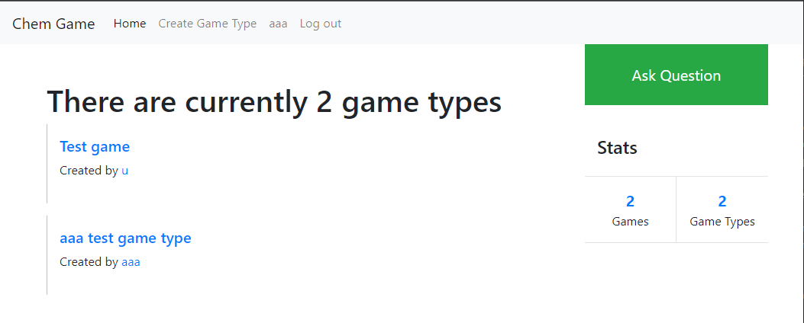
The visitor can also login.
Logging in will promp the user to either make an account or login using the appropriate role.
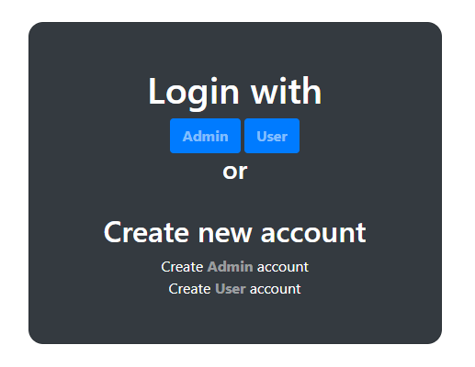
If the user logs in as a USER, the user is redirected to the main menu but with additional options, to create a game or to view the user’s profile.
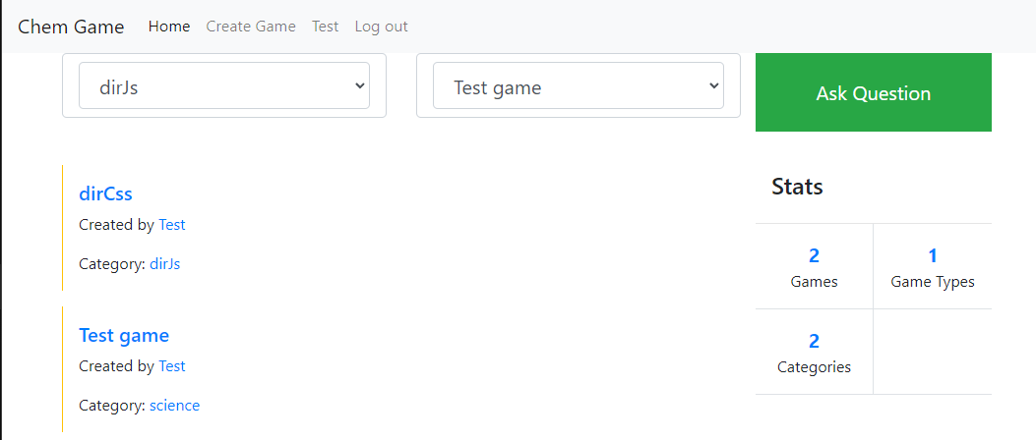
In this example, the user is logged in as Test.
To access the user’s profile, the user needs to navigate to the Test menu tab.
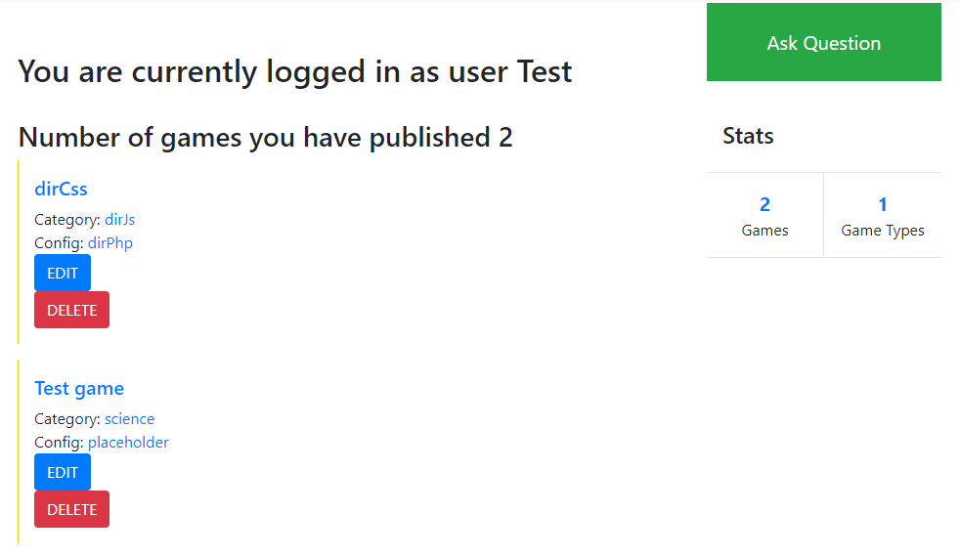
In the user profile, the user can Edit or Delete their created games.
To create a new game, the user needs to navigate to the Create Game menu tab.
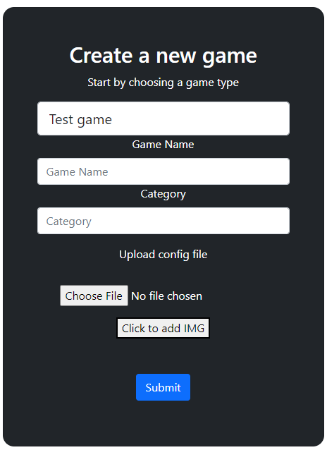
The create game page prompts the user for a form.

After filling out the form, a new game will be created. The user will be prompted with an error message if they create a game that already has the same name. Curretly the platform does not support playing games yet, as such, the user can create a game without adding the required files for one.

If the user logs in as a ADMIN, the user is redirected to the main menu but with additional options, to create a game type or to view the admins’s profile.

In this example, the user is logged in as the admin “aaa”;
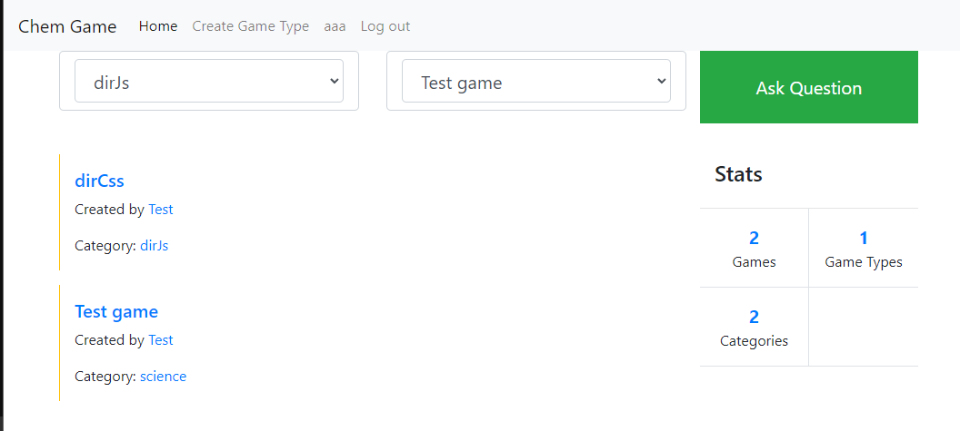
This is the admin’s user profile page
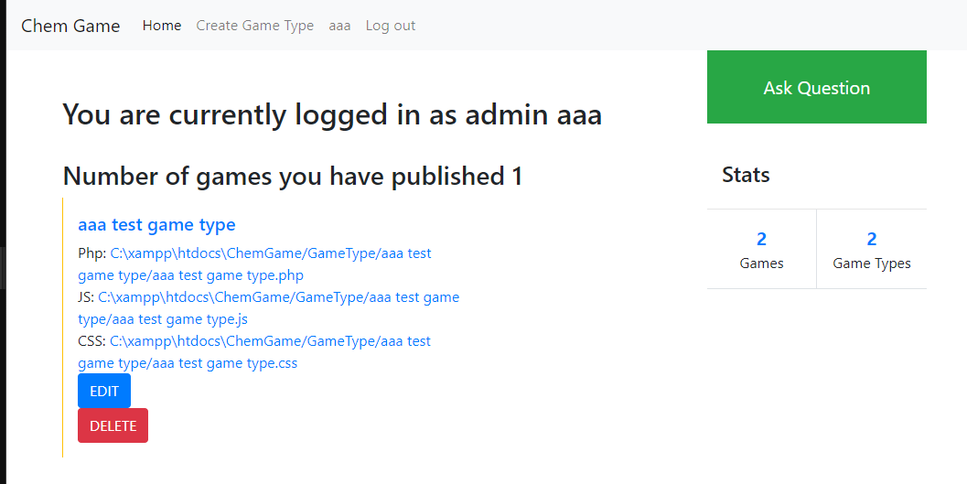
The user can see the games he has created. The files point to a URL from which the game files can be downloaded from (not available yet). The user can delete the gametype (which will delete all games associated with the game type) or edit the game (not available yet). The user will edit the game by downloading the game files, modifying it and reuploading it.

